MIDTERM GRADING RUBRIC

Q1. (a) Greedy Best-first search - Nodes visited: abez Path: abez [1+1]

(b) Iterative-deepening search - Nodes visited: a, adcb, adfacfeabea. adfz, Path: adfz [3+1] (partial marking for order of nodes only when node order shown for all iterations/depths)

(c) A* - Nodes visited: acbfdez Path: acfz [2+1]

(d) Depth-first branch and bound - Nodes visited: acfzb / acfzebed Path: acfz [2+1]

(e) Uniform cost search - Nodes visited: acdbafacedefcbdz Path: abez / acfz [5+1] (partial marking for order of nodes only when length of string returned is atleast half of the actual length(i.e. 8)

Rubrics: for que b and e : partial marks for incorrect order of nodes

Q2. [14 marks]

1. IX
2. I, IV or just IV
3. I, III, V
4. III, VIII
5. I, III

(6) II, IV

(7) II

(8) I

Marking scheme - 1 mark each for (7) and (8), 2 marks each for (1) to (6).

Q3 [13 marks]

Please find a solution [here](https://docs.google.com/document/d/1UIVZbhKueWEPd9699pE0cRWzBiYbE5tQTFQ1Ej9sz8I/edit?usp=sharing).

Q3a) We need to represent an hamiltonian cycle which passes through all the nodes from 1 to n. Thus we can consider that every cycle begins at and ends in node 1. For example, 1, 3, 4, 2 corresponds to cycle 1->3>4->2->1. This string is unique per individual. Also every string has an associated individual. No node is repeated in the string as required.

Q3b) For a given individual C, we compute the total cost of the cycle as sum of its edge cost. The fitness then is defined as f(C) = 1/(total cost of C). Cycles with lower cost have higher fitness.

Q3c) Given an individual C = 1 v_1 v_2 … v_{n-1}, randomly swap any two v_i and v_j nodes among v_1 to v_{n-1}.

Q3d) Let C_1 = 1 v_1 v_2 … v_{n-1} and C_2 = 1 u_1 u_2 … u_{n-1} be two parents. We randomly select two vertices v_i and v_j in C_1. Let S1 = v_i v_{i+1} … v_{j} be the path from v_i to v_j in cycle C_1. Note that such a path always exists as C_1 corresponds to a hamiltonian cycle. Let S2 be a segment of nodes absent from S_1. Nodes in S_1 follow the same order as in C_2. Finally, we define off-spring S by concatenating S_1 and S_2 and rearranging the sequence such that S starts with 1.

E.g. C_1 = 1 4 3 2 5 C_2 = 1 2 3 4 5.

We randomly select 4 and 2 in C_1. Thus, S_1 = 4 3 2.

S_2 = 1 5

Off-spring S = (4 3 2) | (1 5) = 1 5 4 3 2.

S is a valid hamiltonian cycle as it covers all the nodes and does not repeat it.

S has segments 4 3 2 from C_1 and 1 5 from C_2.

Rubric -

1. -1 mark for missing/incorrect state representation.

-1 mark if a hamiltonian cycle can have multiple state representations

-2 mark for missing/incorrect correspondence between a representation and an individual. A representation should be unique to an individual

Note - Permutation of n nodes can lead to non-unique representations for a hamiltonian cycle. For instance a cycle 1->2-3->4->1 can have strings 1 2 3 4 and 2 3 4 1. 1 mark has been deducted in this case.

1. -1 mark for missing/incorrect definition for the fitness function

-2 mark if fitness function can not be used in a genetic algorithm directly. Fitness function should return higher value for a cycle with lower cost

Note - Cost of a hamiltonian cycle does not constitute a fitness function. 2.5 marks are deducted in this case.

1. -2 mark incorrect/missing mutation function
2. -2 mark incorrect/missing approach for cross-over

-1.5 mark if solution does not show that offspring is a valid solution

-1.5 mark if solution does not show off-spring’s inheritance from the parents

Note - Strategy like splitting parent strings at cross over points and recombining them is not sufficient as cross over. Here, the off-spring strings may have repeated nodes and may not correspond to any hamiltonian cycle.

Q4)

1. Out of 2 marks;
   1. at least 4 correct 0.5,
   2. 5 correct: 1,
   3. 6 correct: 1.5 and
   4. 7 correct: 2

Ans: A - {5}, K - {1, 2, 3}, D - {1, 2, 3, 4, 6}, P - {1, 2, 3, 4, 5, 6}, R - {1, 2, 3}, S - {1, 3, 5}, V - {1, 2, 3, 4, 5}

1. 2 marks, Full marks for the correct value else 0

Ans: Value: A, Reason: MRV

1. 4 marks,
   1. Concept explained behind the heuristic: 1 mark,
   2. Complete work was shown for each value of Saptarshi affecting Vipul. Either showing values of V, or telling the length of V for each S, or very satisfactorily explained.: 2 mark,
   3. Partial work shown: - 0.5 mark,
   4. Final answer: 1 mark. Answer written as 5 and no ordering present = -0.5.

For concept, you need to mention somewhere in simple words why your ordering is so. Just naming the heuristic wont count. Even if you havent explicitly mentioned but wrote all steps correctly, I assumed you know the concept (else you couldnt have solved it).  
In complete work, for each value of S, what happens to V is expected to shown. A small deduction (1/4th) is done on partial work.

Final answer is expected to show the ordering, not just a value clearly.

Ans: Name of heuristic: Least Constraining Values

Complete work: Saptarshi has const only with Vipul, V<S.

S=1, V={}

S=3, V={1, 2}

S=5, V={1, 2, 3, 4}

Hence, final answer = {5, 3, 1}. (Even {5,3} has been accepted).

1. 2 marks for constructing the graph correctly, else 0.

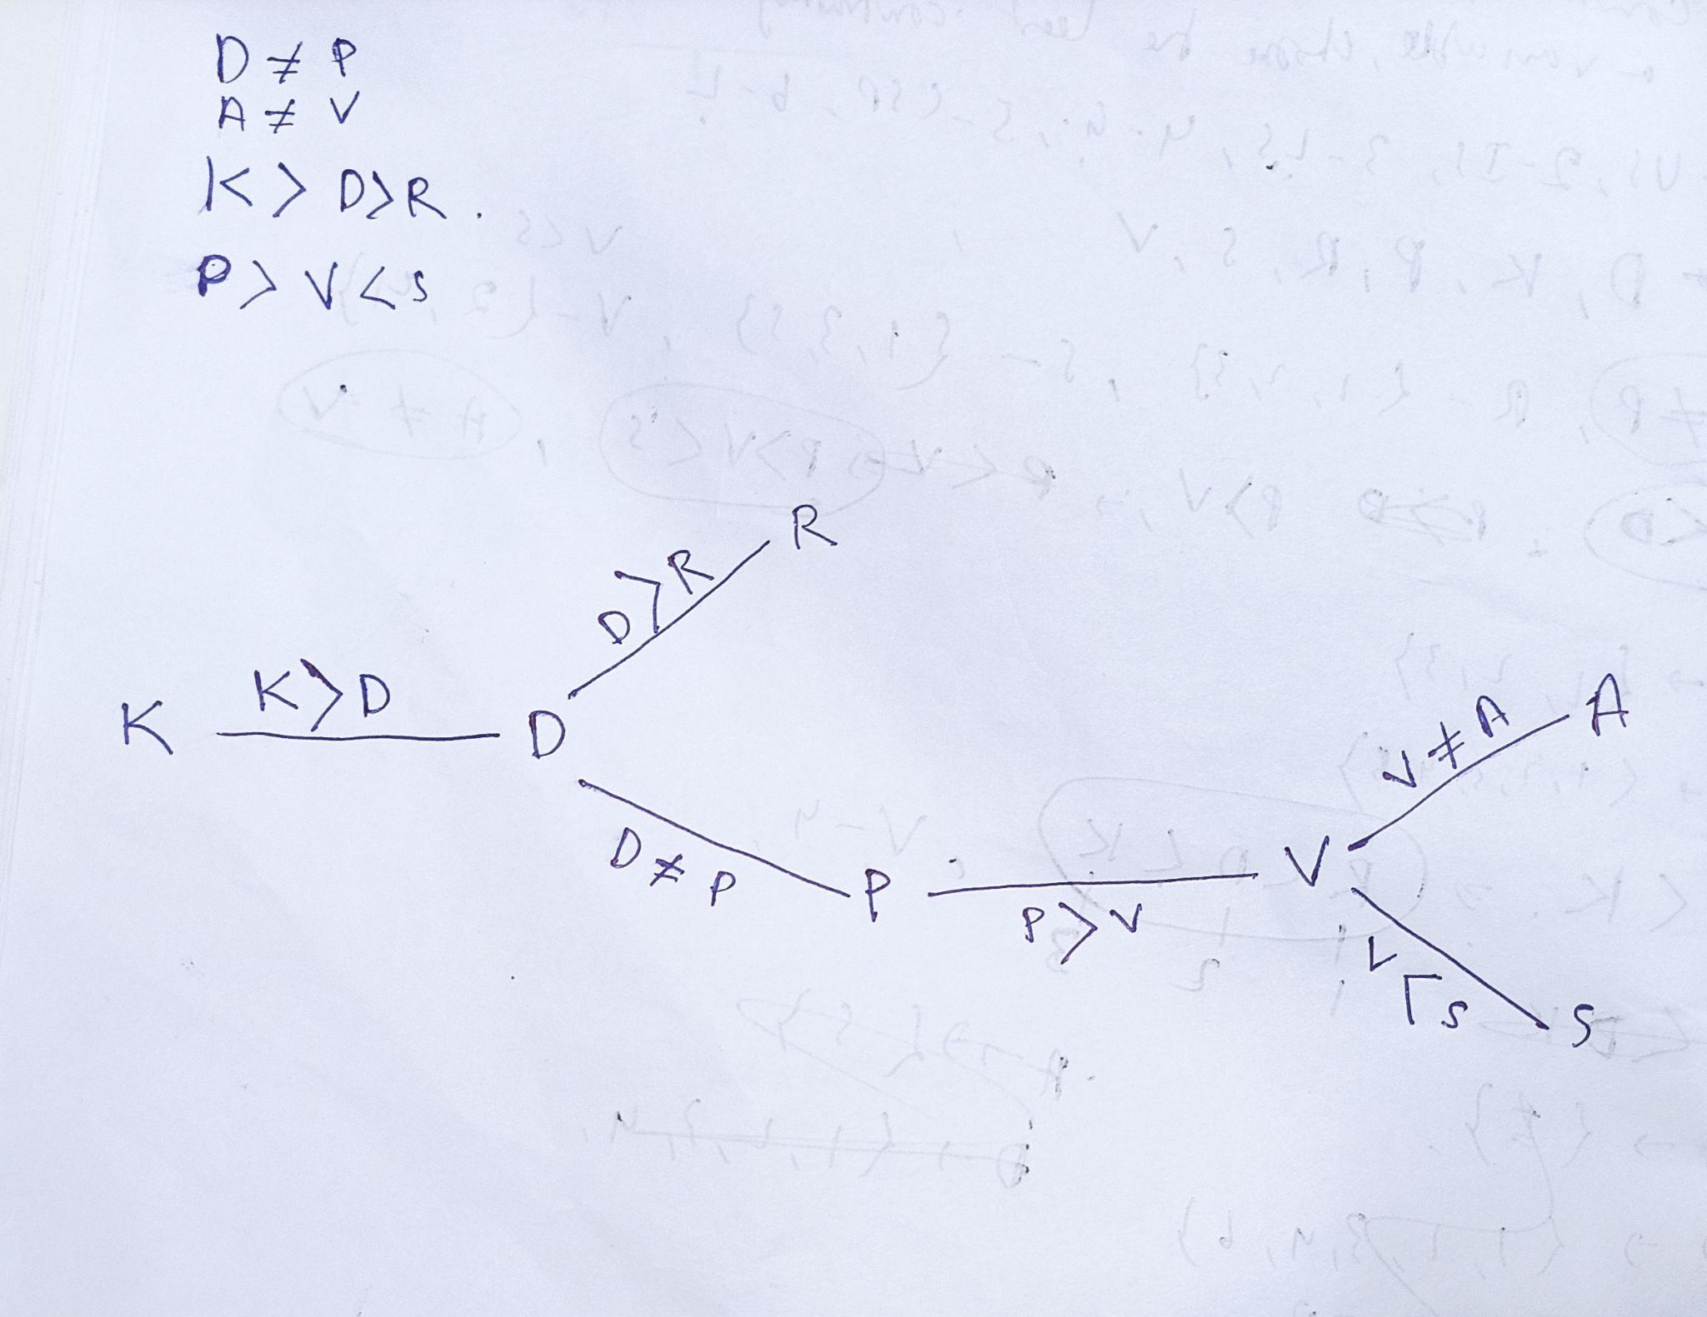

1. 6 marks - All correct

4.5 marks -1 wrong.

3 marks - 2 wrong

1.5 marks - 3 wrong.

0 marks - For all the rest..

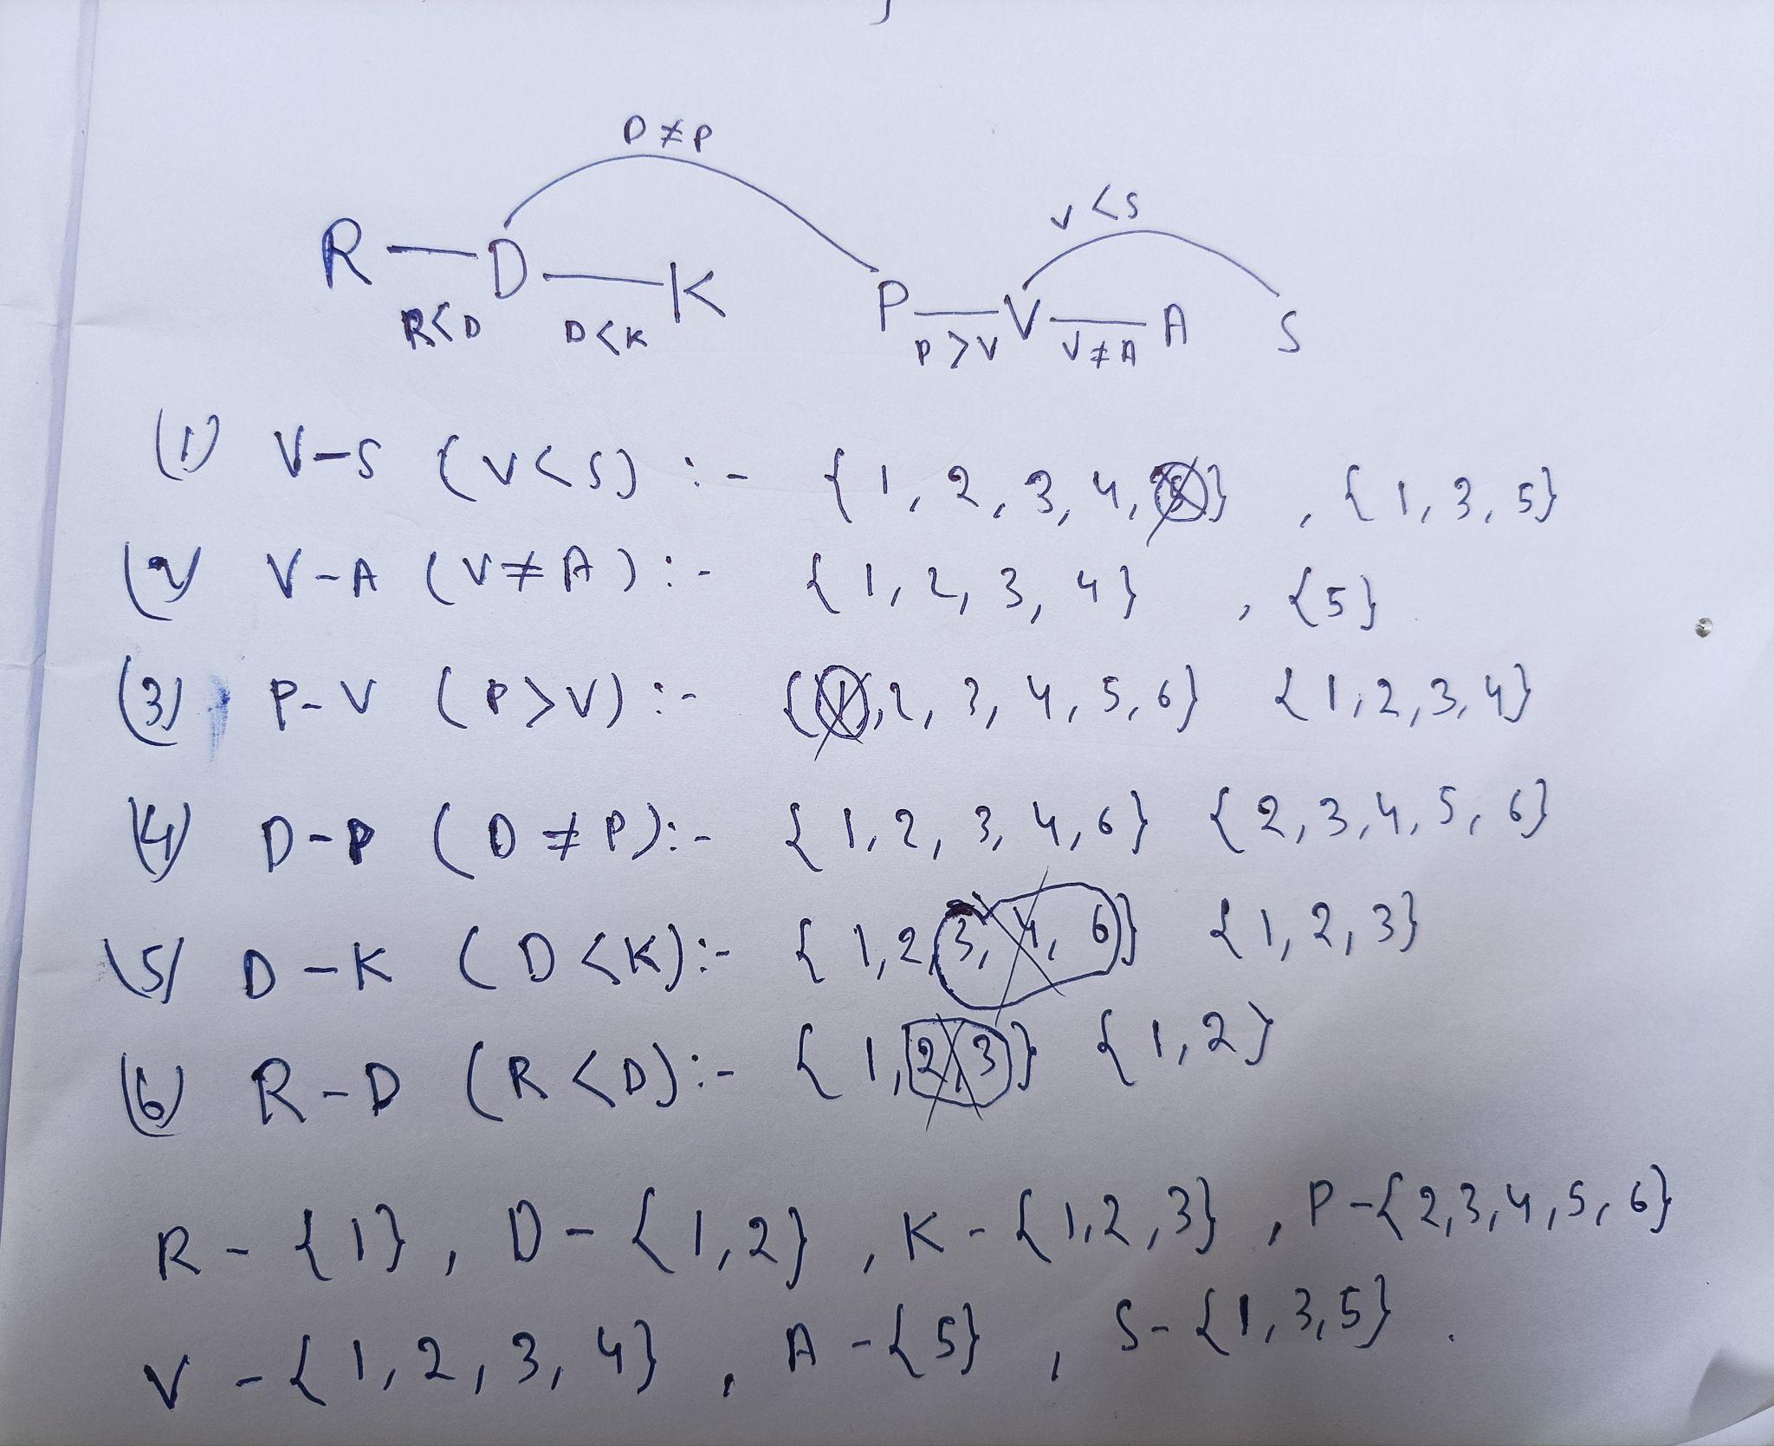

1. at least 4 correct 0.5, 5 correct: 1, 6 correct: 1.5 and 7 correct: 2  
     
   R - {1}, D-{2}, K-{3}, P-{6}, V-{4}, A-{5}, S-{5}

Q8

A. G_i from 1 to 5 = (1,14,16,15,16). S_i from 1 to 5 = (1,17,17,17,18). 0.5 marks for each correct ans.

0.5 for any attempt at all.

1 for a sensible attempt.

1.5 if fairly close to the actual answer.

B. alldiff(s1..s5, g1…g5) **or** for all x,y in s,g alldiff(x,y) **or** any other equivalent form.

2 for correct.

0.5 for each of alldiff(s1..s5) and alldiff(g1…g5) mentioned but not the correct answer.

0.5 for yes.

1 for yes with a justification.

C. V = {TOGRSIP}. 2 for correct. 0 for incorrect. 0.5 for a sane attempt.

D. wg -> {Globe} ws -> {strip} 1 for set wg correct. 1 for set ws correct.

* 0.5 each deducted for any missing / extra letter

E. 7 values. The work can be subjective. 1.5 for answer. 1.5 for working. 1 mark partial if wrong answer obtained due to minor error

g {LB} {OBE} {LBE} {LOBE} -> GL{OBE}{BE}{OBE} + GB{OE}{LE}{LOE} -> (GL{OE}B{OE} = 2) + (GL{OB}E{OB} = 2) + (GBE{L}{LO} = 1) + (GBO{LE}{LE} = 2) = 7

F. G2 should be assigned. L should be the value. 1 mark for each. Partial marks for sane attempts.

Q6)  
A. (8-X1,8-X2,8-X3,.....,8-X7), can give marks to (6-X1, 6-X2,…….6-X7) if explicitly specified that X1 is located on (0,0) (2 points for correct no partials)

B. Rubric used:

* 2 points for (X1 < 4) or (X1 = 4 and X2 < 4)
* 2 points for X1 < X2
* 1.75 points for (X1 <= 4) or (X1 = 4 and X2 <= 4)
* 1.5 for X1 <= 4
* 1 for X1 < 4
* 0.5 for other minor errors but in correct direction

C. Total of 5 other than horizontal vertical symmetries which are 90, 180 and 270 degree rotation symmetry and symmetry among two diagonals (should be explicitly mentioned) (2.5 points for all correct, 0.5 for each correct)

D. yes, 2 symmetries removing X1=1 row and column, symmetry along the centre of the board and diagonal. (2.5 for correct, 1 for yes, 1.5 for stating correct symmetries, 0.75 for each correct symmetry)

E. We dont believe there are new symmetries present. 2 marks. No reasoning expected.

Q5)

1. Game of Chance (the hands you/your opponent are dealt are random)  
   Imperfect Information (can’t see the hand your opponent has been dealt)  
   1 mk for each, no explanation required. No partial marks.
2. Both are equally good (1 mk)  
   A symmetry or probability-based argument as to why (1 mk). Give marks based on discretion if another method is used. 0 for handwaving. 0 if the first part’s answer is incorrect.
3. Subtree values: 0.5 for G2-G1-R1, 0.5 for R1-G1-G2, 1 for R1-R3-G3-G1 and 2 for R1-R3-R2-G2. Cut 0.5 for incorrectly labelled nodes/edges, and 1 if nodes are missing or too many incorrect nodes/edges/extra nodes. Cut 0.5 for not labeling if branches are win or loss. Labels other than 0/1 ok for loss/win  
   1 mark for P(win) = 1  
   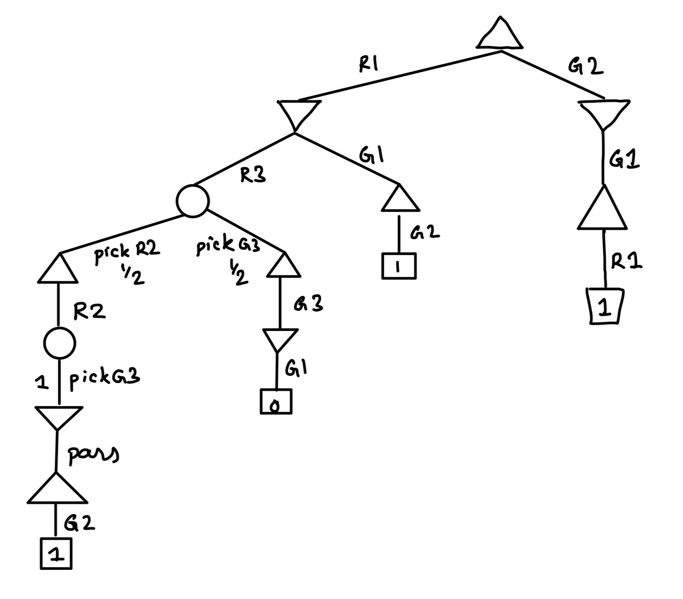
4. Subtree values: R2 = 2 (1+1), G1 = 2.5 (1+1+0.5), G3 = 2(1+1), head node = 0.5. Partial: R2 (0.5 mk for depth 2, 1 mk upto picking G3/G1), G1 (1 mk up till R2/G3 pick, 1 more up till pass), G3 (1 mk upto depth 2).   
   Similar mark deduction as before (-1/-2/-0.5 for no win/loss labels). Labels other than 0/1 ok for loss/win  
   1 mark for P(win) = 2/3  
   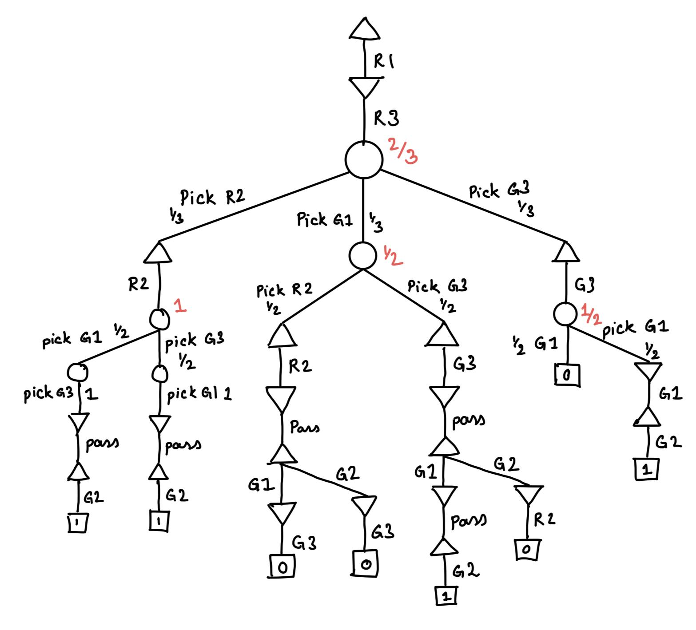

Q7)

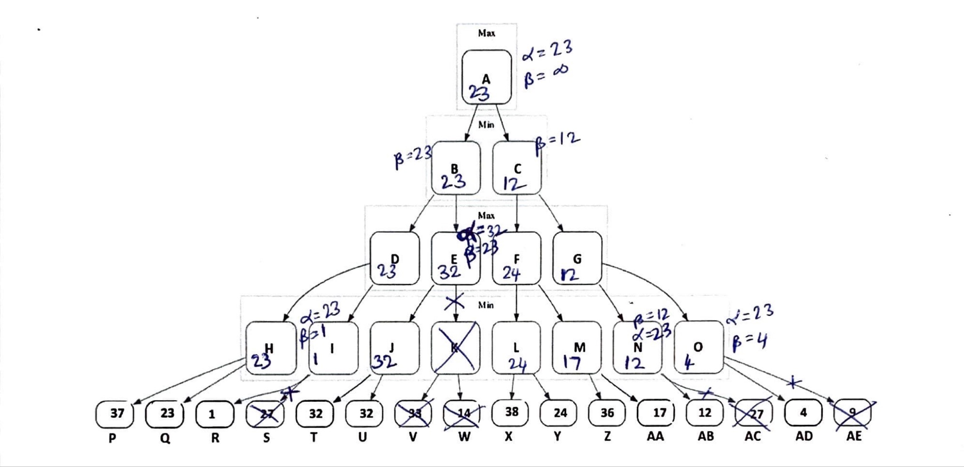

1. Final value= 23 (1 mark)

optimal path: A-B-D-H-Q (1 mark)

(No partial marks)

1. Nodes pruned:

S (1 mark), K (1 mark), V (0.5 mark), W (0.5 mark), AC (1 mark), AE (1 mark)

-0.5 mark per extra node until 7 extra nodes, more than 7 extra: 0

1. AE is last node pruned (1 mark)

For node AE,

α= 23 (1 mk), β= 4 (1 mk)

For node A,

α= 23 (1 mk), β= infinite (1 mk)

1. Box-1: (2 marks)

if e − 2 ≥ β then

return e − 2

end if

(or)

if Max(α,e − 2 )≥ β then

return e − 2

end if

(return value doesn’t matter as parent min-node already has better value so no update will be made based on returned value)

(+1/+0.5 if condition is partially correct Ex- if Max(α,e − 2 )≥ β or Min(β,e + 2 )<=α (Here second condition may result in incorrectly pruning node if e+2<beta))

Box-2 replace with: (4 marks)

v ← Max(v, Min-Value(child , Max(α, e − 2), Min(β, e + 2)))

2 marks for correctly writing new α as Max(α, e − 2)

2 marks for correctly writing new β as Min(β, e + 2)

(Partial marks for variations depending on accuracy)

(+1/+0.5 if some ideas are captured and some extra pruning is achieve in comparison to normal alpha-beta pruning Ex- v ← Max(v, e-2, Min-Value(child , Max(α, e − 2), Min(β, e + 2))) (this may give some extra pruning but misses many possibilities at child node calls)